INDIAN INSTITUE OF TECHNOLOGY

INDORE



ALUMNI PORTAL

Web Application User Guide

Table of Contents

Introduction ….……….…………………………………… pg. 3 Login ……..…………..….………….……………............. pg. 4 New User Registration ..………………………………. pg. 5-6 Home …………………………………………………………. pg. 7 Gallery ……………………………………………………….. pg. 8 Blog ……………………………………………………………. pg.9 Discussion ……………………………………………………. pg. 10 About Us ……………………………………………………… pg. 11 Contact Us …………………………………………………….. pg. 12

**Introduction**

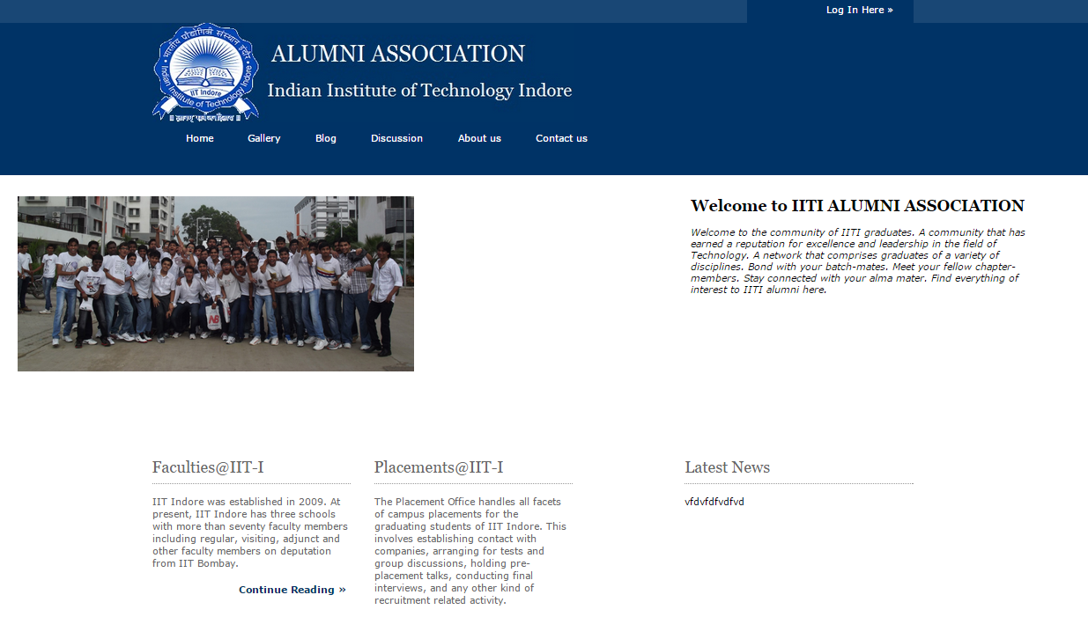

The IIT Indore Alumni Association exists to help you stay connected to IIT Indore, and to each other, wherever you are in your life now. Whatever you're seeking, be it College events and connections in your hometown, an excuse for reunion, a job lead or a mind-expanding magazine, we've got you covered.

The IIT Indore Alumni Association seeks to reach, serve and engage all alumni and students; to foster a lifelong intellectual and emotional connection between the College and its graduates; and to provide the College with goodwill and support.

**Login**

At the top right corner Login Here option is available. Click on the link and a slide panel will appear showing:

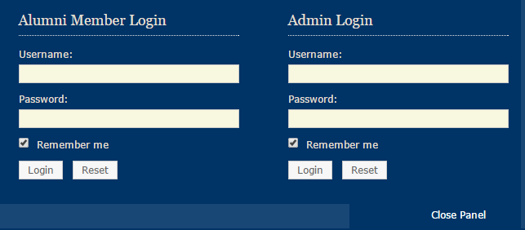

**Users** who have previously registered for the IITI Alumni Association Web Application must login by:

Entering their **Username** in Alumni Member Login.

Entering their **Password** in Alumni Member Login.

Selecting **Login** to access your profile, to view others profile and other resources which are only available when logged in.

Also User can update his profile.

**Administrator** will have access to the whole IITI Alumni Association Web Application only when he will be logged in.

Entering their **Username** in Admin Login.

Entering their **Password** in Admin Login.

Selecting **Login** to have control over databases and the complete web pages to change anything, to add or remove something. Administrator can add news, remove news as per his wish.

**New User Registration**

At the top right corner Login Here option is available. Click on the link and a slide panel will appear showing:

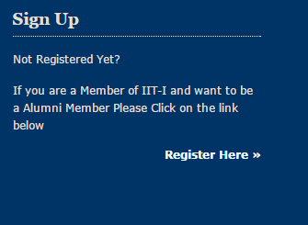

Click on the Register Here >>. You will be redirected to another page.

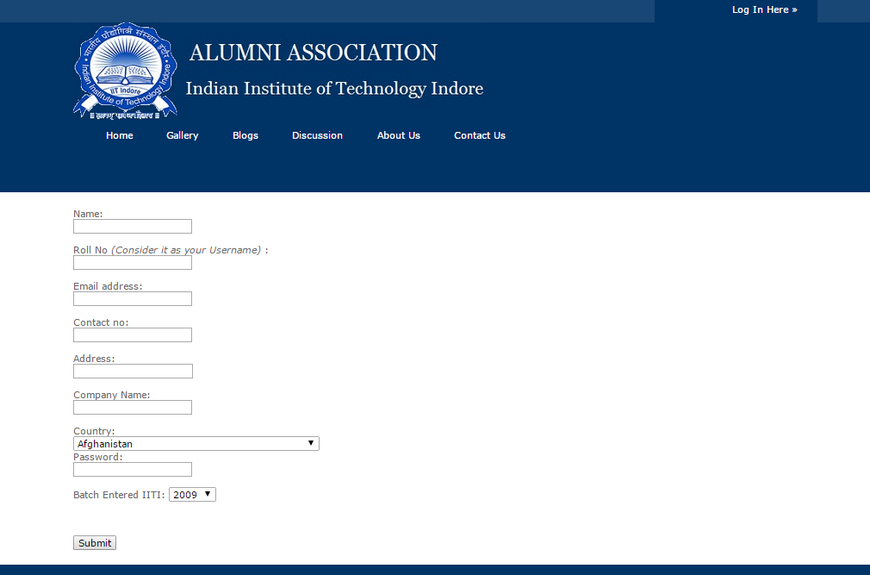

Users will be asked to enter or select the following information (All the fields are required.)

**Name**: Name of the user.

**Roll No.** : Roll No. of the Alumni while he was studying in IIT I.

**Email address**: Email Id of Alumni.

**Contact No.** : Contact no of the Alumni.

**Address**: Current address of the Alumni.

**Company Name**: Company working in.

**Country**: current Company of Alumni.

**Username**: Roll No. of the Alumni entered above.

**Password**: As desired by Alumni (No constraints on password. Totally his/her choice.)

**Batch**: Passing year of Alumni.

After Submitting the data a request will be send to Administrator and once he/she approves you will get a mail showing that you are a part of Alumni Member and your account is active.

**HOME**

The Home page of the Alumni Association welcomes everyone showing the main purpose of the Alumni and IIT I. At the front itself contains the important links like Faculties @IIT-I, placements @IIT-I and the latest news section which will be managed by Administrator. At the top right corner link for login is given where User and Administrator can Log-In and Register.

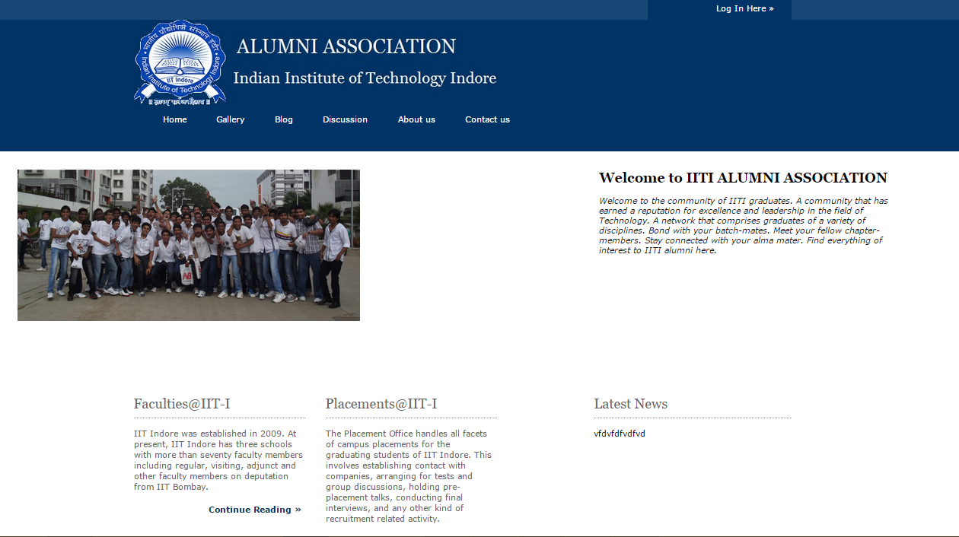

When we scroll down a world map is shown which represents the network of our Alumni Association. And at the bottom the contact address of different campus and offices is given.

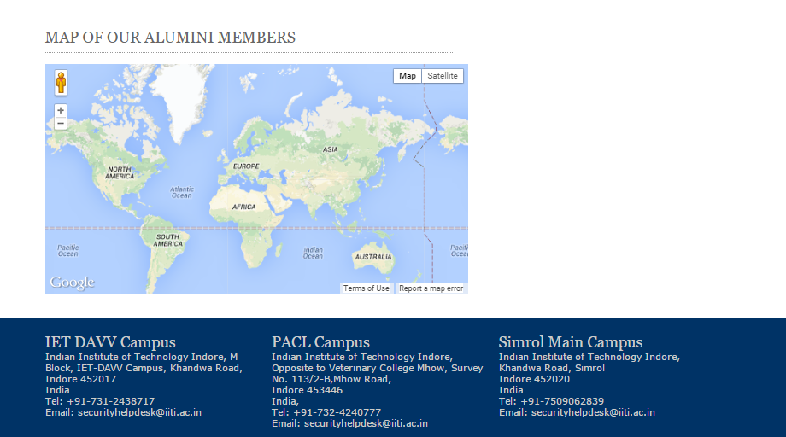

**GALLERY**

In the navigation panel, just adjacent to the Home tab there is Gallery tab which contains all the Pictures related to Alumni functions, there Farewell Treat.

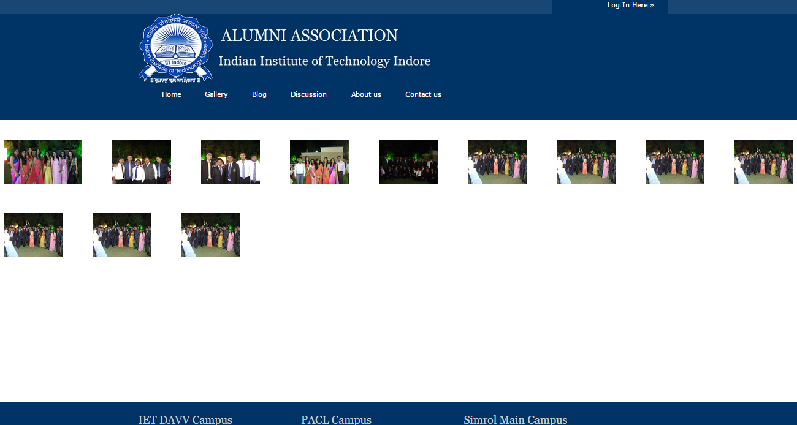

By clicking on any of the picture the same will be magnify and the rest will disappear in the background.

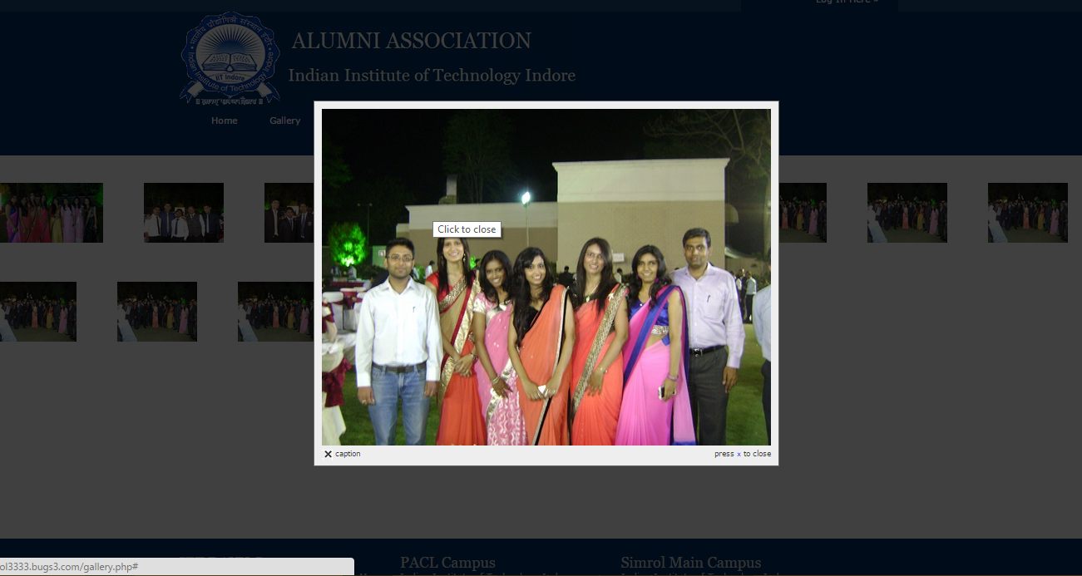

Similarly, you can see the other pictures.

**BLOG**

In the Navigation panel, Bolgs page will only open when the User is login, if he is not the page will show to login first.

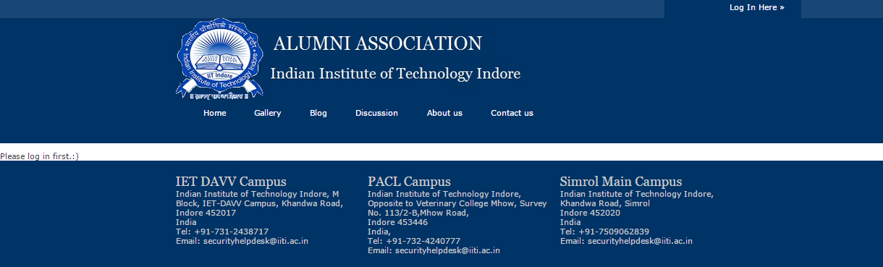

After Logging in User can successfully post and see the blogs of others users.

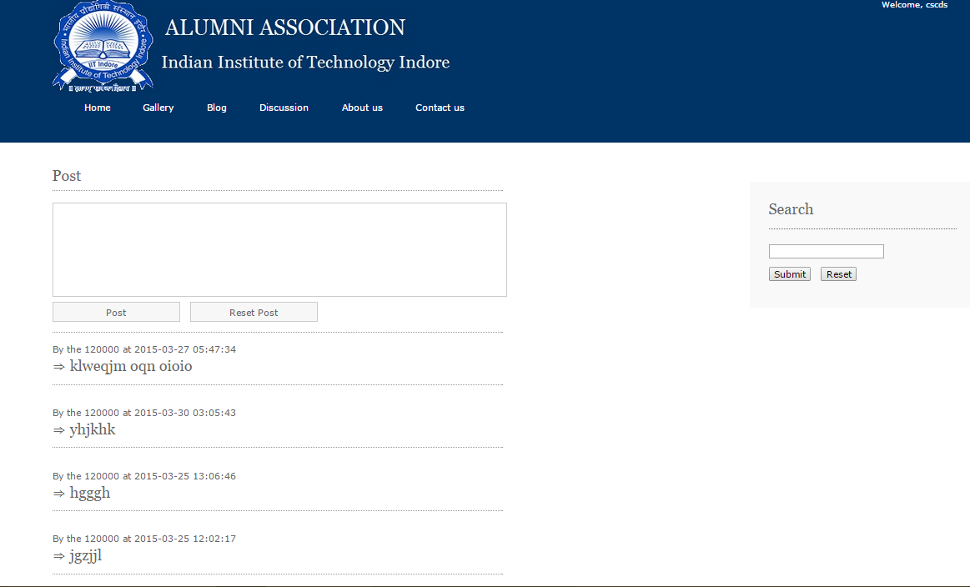

In the Blog, User can also search for existing blogs or to look for something. At the right side of the page search bar is there to search things.

**DISCUSSIONS**

Similar to Blog, Discussion will only function when user is logged in. Once logged in, Alumni can ask questions, answer to the pre-existing ones and see others answers too.

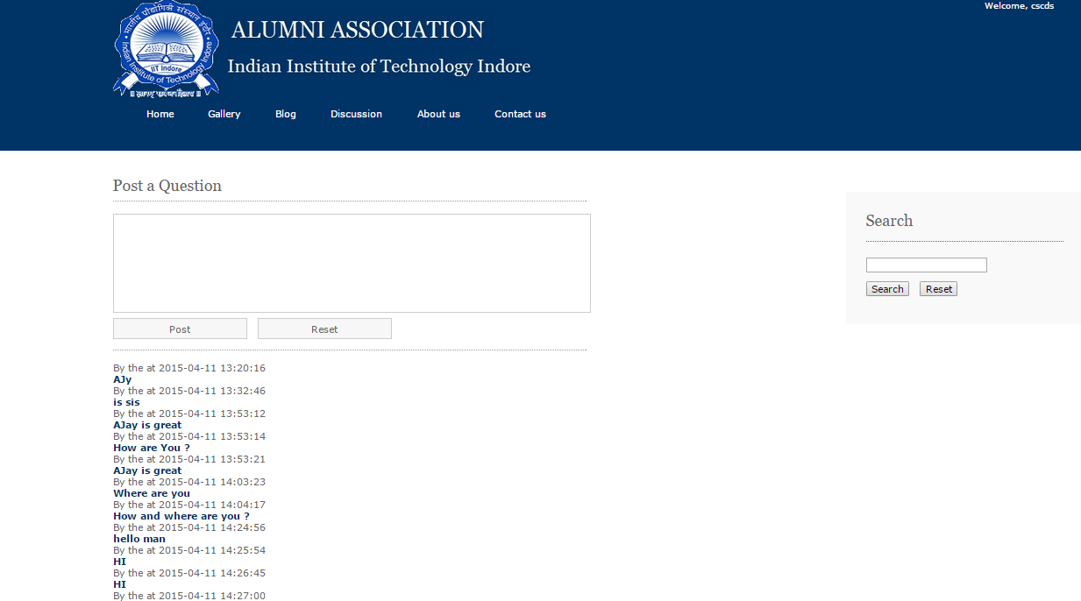

To view answers of a particular question, click on the following question, user will be redirected to the answer page, where user can see others answer or post one of its own answer.

Here also at the right side, Search bar is given to search among the questions and answers.

**ABOUT US**

About Us page of the Alumni Association gives you a view of the information about Alumni Association IIT Indore and also the Mission on which it is running.

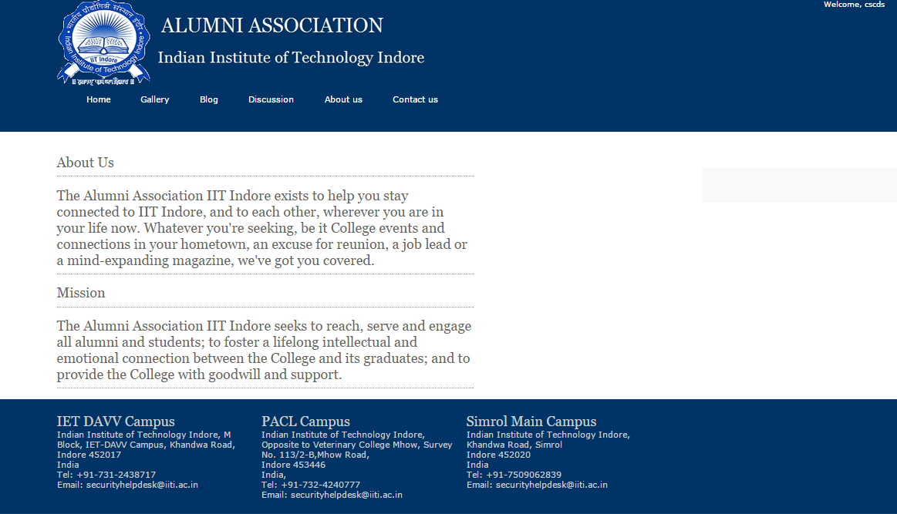

**CONTACT US**

For any queries and problems while registering in the Alumni Association or any other problem Contact Us page is made for this.

A form is there in which you have to enter your email id, subject of the problem and a brief explanation of the problem in message box.

